**OUTPUT :-**

**Step 1:-**Visit the official website of Flutter.

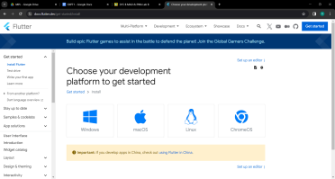

**Step 2:-**Select the type of App

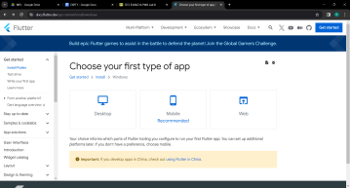

**Step 3:-** Download Flutter SDK

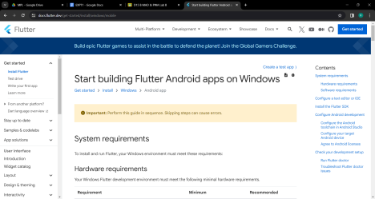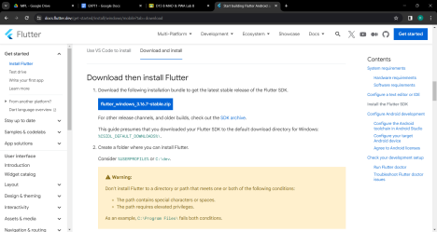

**Step 4:-** Extract the ZIP File

**Step 5:-**Add Flutter SDK path to environment variables

Go to extracted file -> select Bin Path -> search for environment variables -> Edit Path -> Paste the copied path -> OK

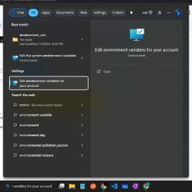

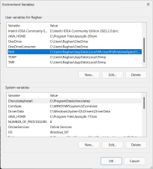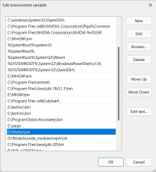

**Step 6:-** Visit Official Site for Android Studio

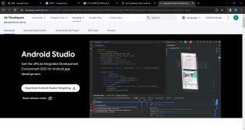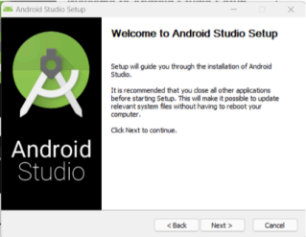

**Step 7:-**Install Android SDK

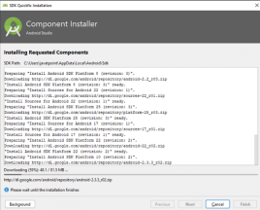

**Step 8:-**Accept Android License

**Step 9:-**Install AVD (Android Virtual Device) from Android Studio Device Manager -> Add Device ->Select Model ->Select System Image - > Finish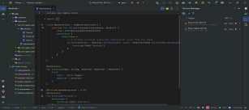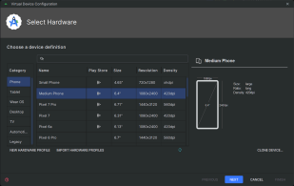

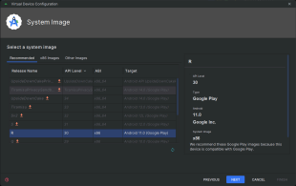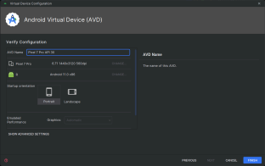

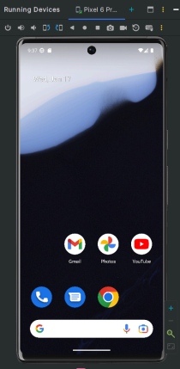

**Step 10:-** Open command prompt on your machine and run command flutter doctor’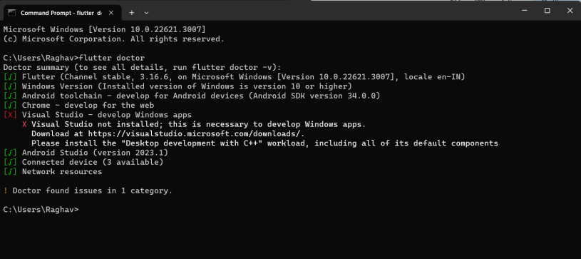

**Step 11:-** Resolve Errors if any

**Step 12:-** Install Dart and Flutter plugins in Android Studio

Settings -> Plugins -> Search for Dart and Flutter

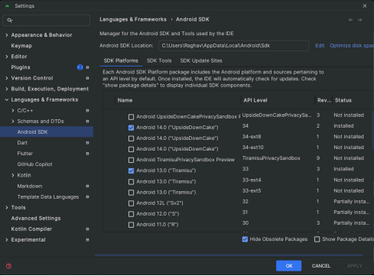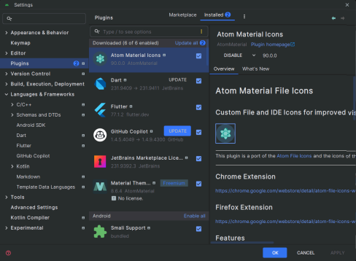

**Conclusion:-** In this experiment , we installed Flutter SDK , Android Studio , Dart and Flutter Plugins . Also we accepted an Android Licence and Installed Android SDK and AVD using Android Studio.